Name____________________________________
GT/PAP Algebra 2 Summer Assignment
Please complete all your work on this assignment – you must show all of your work to receive credit! Write your final answer in the blank provided.
*This will be due the first 2 days of school at the beginning of class. There will be 10 points deducted per block late.*
- Simplify the following fractions. Remember – you must show your work. If you type this into the calculator and write your answer down, you will *not* receive credit.
Answers
1. _____
2.
3.
4.
5.
6.

7.

8.

9.

10.

11.

12.
- $\frac{4}{9}*\frac{7}{4}$ 2. $\frac{1}{2}÷\frac{8}{7}$

3. $\frac{\frac{-1}{2}}{\frac{5}{4}}$ 4. $\frac{\text{2}}{\frac{\text{3}}{\text{2}} \text{- }\frac{\text{4}}{\text{3}}}$

5. $\frac{\frac{\text{1}}{\text{4}}\text{+}\frac{\text{5}}{\text{4}}}{\text{4}}$ 6. $\frac{\frac{\text{4}}{\text{5}}}{\frac{\text{2}}{\text{25}} \text{- }\frac{\text{5}}{\text{16}}}$

- Simplify the following expressions.
7. $6x-2y-3x+2y$ 8. $4\left(14c-10d\right)-6(d+4c)$

9. $8xy-7y-(3-6y)$ 10. $\frac{1}{2}\left(17-4x\right)-\frac{3}{4}(6-16x)$

- Solve the following equations for the variable.
11. $3y+16=22$ 12. $\frac{1}{2}x-2=\frac{1}{3}x$

13. $4x+7=9x-13$ 14. $\frac{4}{5}x-7=16$
Answers
13. _____
14.
15.
16.
17.
18.
19.
20.

21.

22.

15. $-7x=15-2x$ 16. $10x+6=8-2(x+6)$

17. $24-\frac{x}{3}=6$ 18. $34-10w=6w+2$

19. $3\left(x-4\right)+4\left(x+8\right)=10-5(x-3)$ 20. $\frac{2}{3}x-\frac{1}{4}=\frac{1}{6}x-\frac{1}{9}$

- Solve the following word problems.
21. A farmer plants corn and wheat on a 180-acre farm. The farmer wants to plant three times as many acres of corn as wheat. Write a system of linear equations that represents this situation. How many acres of each crop should the farmer plant?

22. You have $32 to spend on supplies for your science fair project. If you buy two plants for experiments, you will have $18 left for other supplies. How much is each plant?

- Solve each equation for the indicated variable.
Answers
23. _____
24.
25.
26.
27.
28.
29.
30.

31.
32.
33.
34.
35.
36.
37.
38.
23. $4x+3y=15;for y$ 24. $V=\frac{1}{3}πr^{2}h;for r$

25. $PV=nRT;for R$ 26. $F=G\frac{mM}{r^{2}};for r$

27. $P=2l+2w;for w$ 28. $V=πr^{2}h;for h$

29. $\frac{x}{r}-h=4;for x (r≠0)$ 30. $\frac{1}{x}+a=b;for x (x≠0)$

- Factor each quadratic expression.
31. $x^{2}+9x+14$ 32. $x^{2}-10x-75$

33. $x^{2}+x-20$ 34. $x^{2}-29x+100$

35. $x^{2}-5xy+{6y}^{2}$ 36. $x^{2}-21x+54$

37. $x^{2}-30x+225$ 38. $x^{2}+20x+91$

- Write the equation of the line described.
Answers

39. _____

40.

41.

42.

43.

44.

45.

Write the equation in slope-intercept form.
39. The line with a slope of $\frac{5}{3}$and a y-intercept of $-2$.

40. The line passing through $(-4, 6)$ and parallel to the line $y=3x+8$.

41. The line passing through $(1, 2)$and perpendicular to the line $y=4x+3$.

42. The line with an x-intercept of $-1$and a y-intercept of $6$.

43. The line passing through $(8, 3)$ and $(2, -1)$.

44. The line with a y-intercept of -6 and parallel to the line $5x+4y=1$.

45. The horizontal line through (5, -7).

- Graph the following equations.

46. $y=-3x+1$ 47. $5x+2y=4$
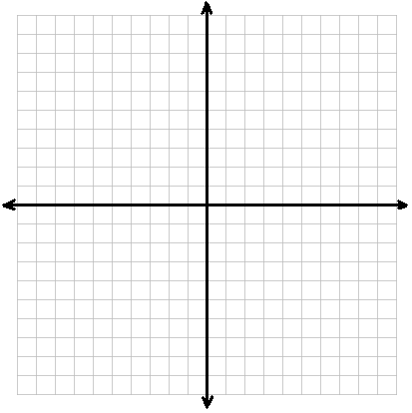

48. $y=\frac{1}{2}x-4$ 49. $-2x-3y=9$

50. $y=x$ 51. $x=3$

BONUS:
Given $f\left(x\right)=x^{2}+2x-9$ and $g\left(x\right)={(x+1)}^{2}$, evaluate $f\left(a+1\right)+g(a+1)$.

